On the 11th February 2020, the President of Zanzibar and the Chairman of the Revolutionary Council H.E Dr Ali Muhamed Shein launched Vol. 10 of Zanzibar Yearbook of Law of 2018.
The launching was part of the celebration of Zanzibar law day. Zanzibar Yearbook of Law is published by the Zanzibar Legal Services Centre and contains peer-reviewed scholarly articles on diverse matters of law. ZYL will soon be out for circulation.
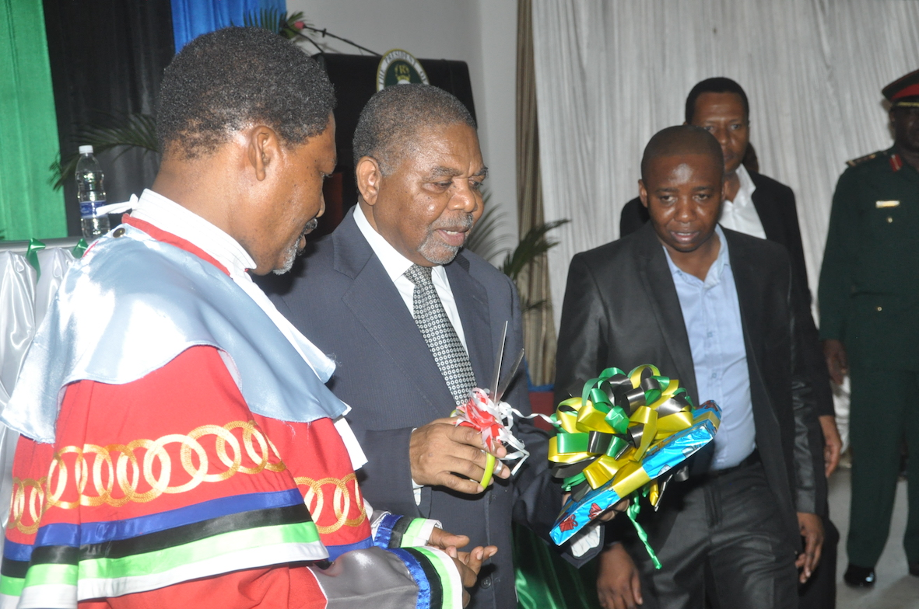
H.E Dr Ali Mohamed Shein launching the Zanzibar Yearbook of Law
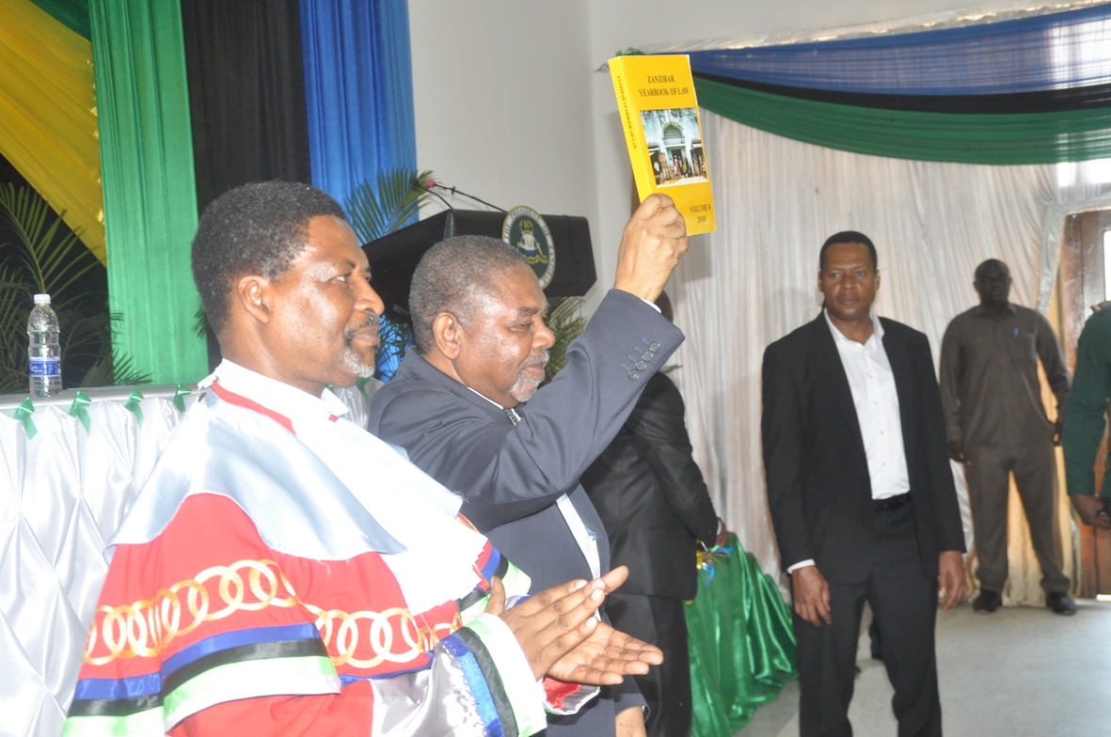
Dr Shein raising the ZYL after its launching. On his right is the Chief Justice of Zanzibar, Hon Omar Othman Makungu,

